**Custom Random String**

**Description**

The Java Action will be useful to create a random string by inputting some parameters.

The input parameters will decide the range of Data type.

The Input parameters will be:

1. Uppercase Alphabet Range
2. Lowercase Alphabet Range
3. Number Range
4. Special Character Range

The return type would be string which will return the Custom Random String based on the input choice made.

**Typical Usage Scenario**

There are cases where User wants to generate the random string by providing the range of data type. User can provide it. In the Special Character category, he can mention which Special Characters should be in the Output by predefining it. The Generated String will have shuffled Characters

**Pre Requisites**

NA

**Features and Limitations**

A single Component will be helpful to generate Random String according to Range and Shuffle it.

**Dependencies**

Require Mendix 9.1.0 or above.

**Installation**

1. Download the Module from marketplace.
2. Use the Java Action with specific inputs.
3. Store the output in the Varible

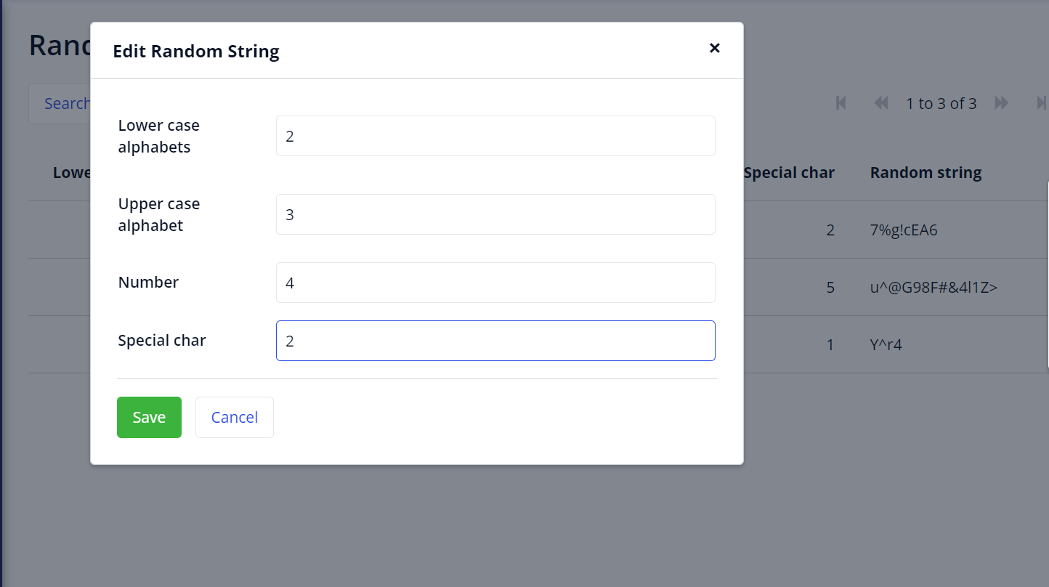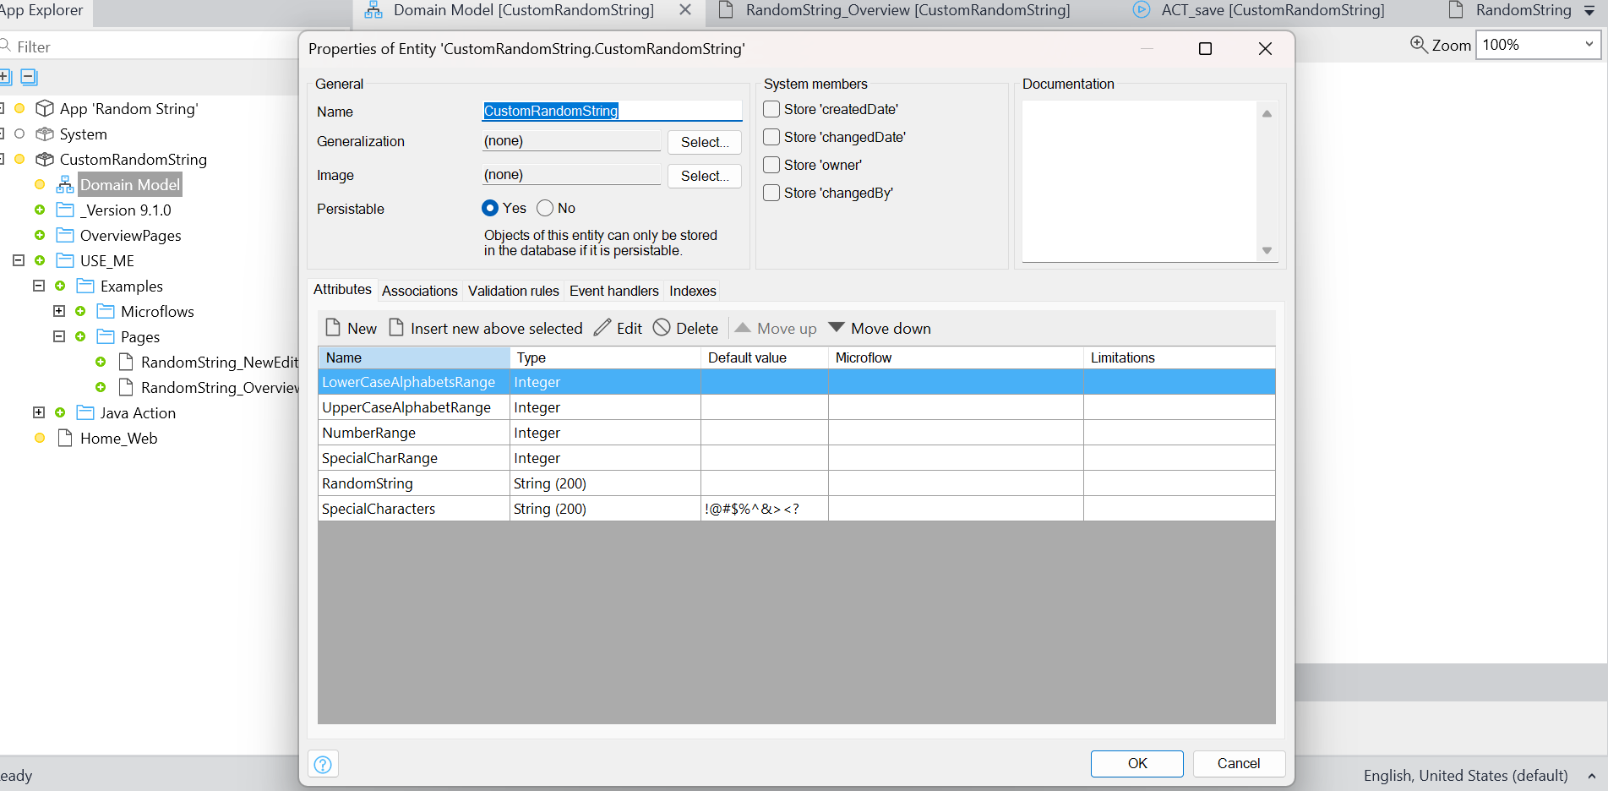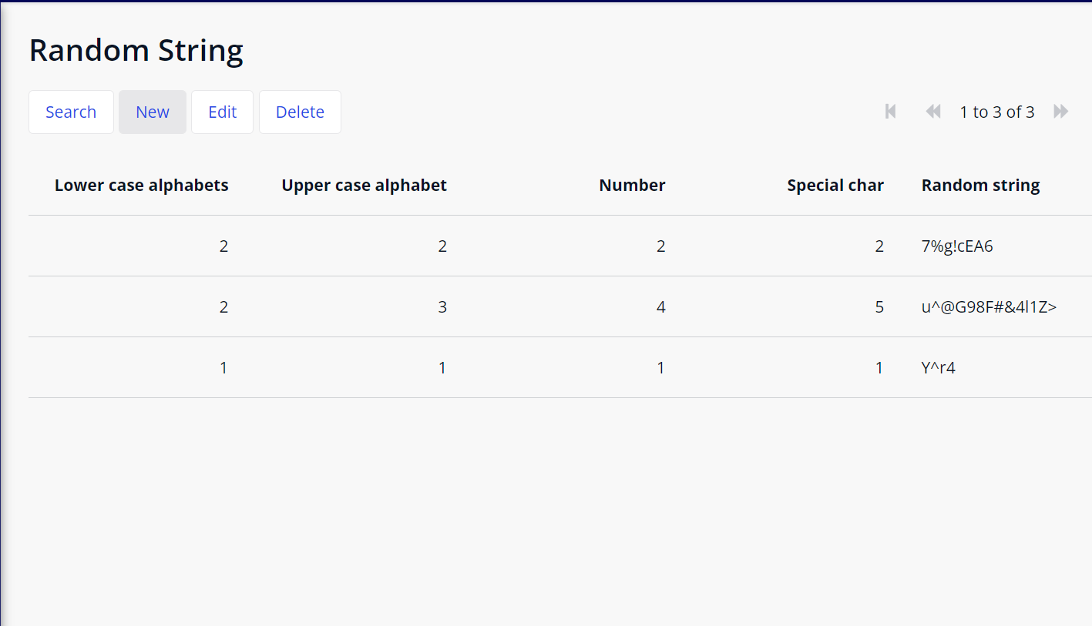

**Configuration: NA**

**Category: Module**

**Subcategory: All**

**Visibility: Public Marketplace**

**Studio Pro Version:**9.1.0 or above.